20.50: The efficiency of the first engine is 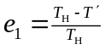and that of the second is 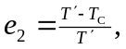 and the overall efficiency is
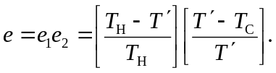
The first term in the product is necessarily less than the original efficiency since 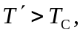 and the second term is less than 1, and so the overall efficiency has been reduced.

